# Software Requirements Specification

# for

# ONLINE HOSPITAL MANAGEMENT SYSTEM

Version 1.1 approved

Prepared by AYUSH DEV

CSE TMSL

15-08-2023

# Table of Contents

Table of Contents 2

1. Introduction 4

1.1. Purpose 4

1.2. Scope 4

1.3. Existing applications: 4

1.4. References 4

2. Overall Description: 5

2.1. Product Perspective: 5

2.2. User Classes and Characteristics 5

2.3. Software Requirements: 5

2.4. Hardware Requirements: 5

2.5. Customer Survey 5

3. Functional Requirements 7

3.1. User Registration and Authentication 7

3.1.1. Sign Up 7

3.1.1.1. For User 7

3.1.1.2. For Hospital 7

3.1.2. Email Verification 7

3.1.3. Log-In 7

3.1.4. Password Reset 7

3.2. Profile Management 8

3.2.1. Profile Creation 8

3.2.2. Profile Deletion 8

3.2.3. Edit Profile 8

3.3. For Patients 8

3.3.1. Register Patient 8

3.3.2. Update Details 8

3.3.3. Search Doctors 8

3.3.4. Appointment Scheduling 9

3.3.5. Access Records 9

3.3.6. Raise Query 9

3.4. For Hospital/Management 9

3.4.1. Approve Appointment 9

3.4.2. Prescription Management 9

3.4.3. Add/Update Medical Records 9

3.4.4. Billing and Payments 9

3.4.5. Inventory Management 9

3.4.6. Reporting and Analytics 10

4. Non-Functional Requirements 10

4.1. Performance Requirements 10

4.2. Security Requirements 10

4.3. Scalability Requirements 10

4.4. Usability Requirements 10

4.5. Compatibility Requirements 10

5. Assumptions & Dependencies 11

6. Design & Implementation Constraints 11

7. Conclusion 11

# Introduction

The Online Hospital Management System (OHMS) is a web-based application that aims to streamline the administrative, clinical, and operational processes of a hospital. It provides a centralized platform for patients, doctors, nurses, and administrative staff to manage and access information efficiently.

## Purpose

The purpose of this SRS is to define the comprehensive set of requirements for the development of a feature-rich and user-friendly Hospital Management System. The purpose of OHMS is to automate various hospital processes, improve patient care, enhance communication among stakeholders, and simplify the overall management of the hospital.

## Scope

OHMS will include modules for patient registration, appointment scheduling, medical record management, prescription management, billing, and administrative tasks such as user management and reporting. According to customer requirements, the software to be developed will consist of these databases:

## Existing applications:

Here is a list of some similar platforms widely used by the people:

* Aarogya
* MocDoc
* MediXcel

## References

* <https://www.slideshare.net/>
* <https://www.studocu.com/>
* <https://www.academia.edu/>
* <https://www.scribd.com/document/247913699/SRS-for-Hospital-Management-System>

# Overall Description:

## Product Perspective:

HMS will be a standalone web-based application integrated with external systems such as payment gateways, lab systems, and diagnostic equipment. It will interact with patients, doctors, nurses, and administrative staff.

## User Classes and Characteristics

* **Regular Users:**
  + Age: 18 years or above.
  + Technical Proficiency: Basic computer literacy and familiarity with web applications.
  + Usage Frequency: Monthly or Quarterly usage.
* **Administrators:**
  + Role: Platform moderators and support personnel.
  + Technical Proficiency: Advanced knowledge of the platform's backend systems and moderation tools.

## Software Requirements:

* A database like DBMS (MySQL) to store the details of the users.
* A web browser like Chrome or the app of the said application.

## Hardware Requirements:

* A device (Computer/ laptop/ android/ iOS) with at least 2 GB RAM
* Hard disk space required - 250 MB

## Customer Survey

Forms response chart. Question title: How often do you visit hospital physically?
. Number of responses: 21 responses.

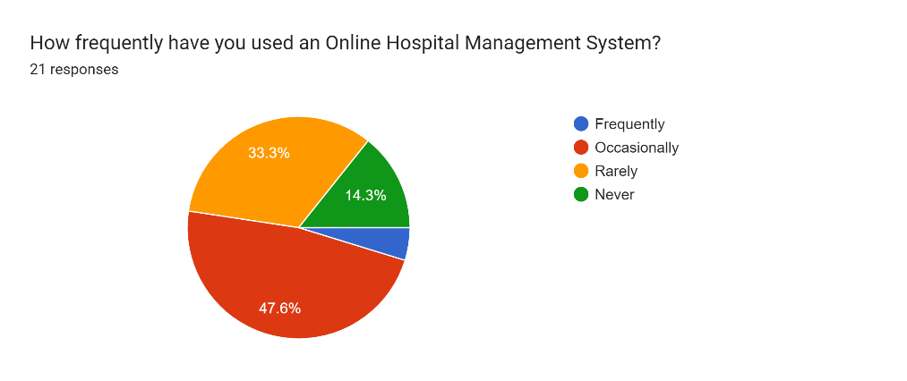Forms response chart. Question title: How satisfied are you with the overall functionality of existing online hospital management systems?
. Number of responses: 21 responses.

Forms response chart. Question title: Which features did/would you find most useful?
. Number of responses: 21 responses.

Forms response chart. Question title: How important is the ability to schedule appointment and access medical records within the system for you?
. Number of responses: 21 responses.

# Functional Requirements

## User Registration and Authentication

### Sign Up

* Users shall be able to register for an account using a valid email address or phone number.

#### For User

* **Input:**
* Name of User
* Date of Birth
* Address
* Contact Details
* Create Password
* Re-enter Password
* Captcha
* **Output:** OTP is sent to the registered email-id/phone no. consisting of membership ID.

#### For Hospital

* The hospital/admin shall be able to login to the portal.
* **Input:**
* Name
* Contact details
* Admin ID
* Password
* **Output:** Admin/Hospital is logged-in into the system.

### Email Verification

* **Input**: Users shall receive an email with a verification link after registration.
* **Output**: Clicking the verification link shall mark the account as verified and enable login.

### Log-In

* **Input**: Users shall be able to log-in using their correct credentials.
* **Output**: The user is logged in.

### Password Reset

* Users shall be able to reset their passwords securely if they forget their login credentials.
* **Input:** Go to “Forget Password”. Choose to reset password via OTP sent to the registered email id or mobile number.
* **Output:** Password has been changed to a new one.

## Profile Management

### Profile Creation

* Users shall be able to create and manage their profiles, including personal information.
* **Input**: Users shall fill in the following details:
* Name
* Date of Birth
* Email ID
* Contact Details
* Medical History
* **Output**: User’s profile is created.

### Profile Deletion

* Users shall have the option to delete their profiles and associated data.
* **Input**: Go to “Delete Profile” option. Enter your password for verification.
* **Output**: Profile has been deleted.

### Edit Profile

* Users shall have the option to edit their profiles and associated data.
* **Input**: Go to “Edit Profile” option. User can edit or update the following details:
* Profile picture
* Phone no.
* Email ID
* Address
* **Output**: Profile has been updated.

## For Patients

### Register Patient

* **Input**: Click on “Register” and fill registration form, including personal and medical details.
* **Output**: The patient is registered.

### Update Details

* **Input**: Click on “Access and Update” to change any information in the profile.
* **Output**: The profile is updated accordingly.

### Search Doctors

* **Input**: Search for available doctors based on specialization, location, and availability.
* **Output**: The list of available doctors is displayed.

### Appointment Scheduling

* **Input**: Request for appointments for a particular doctor on a specific date.
* **Output**: Appointment is scheduled for a particular date.

### Access Records

* **Input**: Click on “View Records” to access medical reports, test results, past checkups etc.
* **Output**: The required details are displayed to the user.

### Raise Query

* The patient can raise a query to the hospital management or to the appointed doctor.
* **Input:** Click on “Ask Query” option and type in the question.
* **Output:** The management/doctor receives the query to resolve.

## For Hospital/Management

### Approve Appointment

* Doctors can approve appointments based on their availability.
* **Input**: Select to approve among the list of requested appointments.
* **Output**: The selected appointment is approved.

### Prescription Management

* Doctors can generate digital prescriptions with accurate medication details.
* **Input**: Click on “Prescribe” to generate prescription.
* **Output**: Users and pharmacists can access prescriptions for dispensing medications.

### Add/Update Medical Records

* **Input**: Create or update electronic medical records, including patient diagnoses and treatment plans.
* **Output**: Updated medical records are uploaded on the database.

### Billing and Payments

* **Input**: Bills are generated automatically based on services provided.
* **Output**: Patients can view their bills online and make payments through integrated payment gateways.

### Inventory Management

* **Input**: Administrative staff can update inventory levels and item details.
* **Output**: Automated alerts for low-stock items to procurement staff.

### Reporting and Analytics

* **Input**: Various reports can be generated, including patient statistics, financial summaries, and appointment history.
* **Output**: Reports can be exported in formats such as PDF and Excel.

# Non-Functional Requirements

## Performance Requirements

* The system should be able to handle a large number of concurrent users without significant degradation in response time.
* The response time for critical operations, such as appointment booking and patient record retrieval, should be less than 2 seconds.

## Security Requirements

* User authentication and authorization mechanisms should be implemented to ensure that only authorized personnel can access sensitive patient data.
* All communication between users and the system should be encrypted using secure protocols (e.g., HTTPS).

## Scalability Requirements

* The system architecture should be designed to allow easy scaling to accommodate increasing user load without major modifications.
* The database should support horizontal scaling to manage growing patient and medical data.

## Usability Requirements

* The user interface should be intuitive and user-friendly, catering to users with varying levels of technical expertise.
* The system should be accessible via standard web browsers and be compatible with different devices (e.g., desktops, tablets, smartphones).

## Compatibility Requirements

* The platform shall be compatible with various screen resolutions, devices, and browsers to ensure a consistent user experience.
* The codebase should be well-organized and documented to facilitate future maintenance and updates.

# Assumptions & Dependencies

**Assumptions:**

* Users have basic computer literacy and familiarity with web applications.
* System development complies with consistent regulations.
* Users will have access to a stable internet connection for using the platform.

**Dependencies:**

* System development depends on the selection and implementation of a suitable database system, affecting data storage and retrieval efficiency.
* A well-designed user interface enhances user experience and usability, impacting how effectively users can interact with the system.
* The platform's database system must be scalable and capable of handling a growing user base and content volume.

# Design & Implementation Constraints

* The platform's user interface shall be designed following a mobile-first approach to ensure responsiveness and optimal user experience on mobile devices.
* Additionally, the platform shall be developed using industry-standard programming languages and frameworks, adhering to best practices for security and performance.
* OHMS will be developed using modern web development technologies and frameworks.
* Compliance with relevant healthcare data protection laws and regulations is mandatory.

# Conclusion

In conclusion, this Software Requirements Specification (SRS) outlines the comprehensive set of requirements for the development of an efficient and effective Online Hospital Management System. The system's primary focus is to streamline the management of hospital operations, enhance patient care, and provide a seamless experience for both healthcare professionals and patients.

This SRS serves as a foundation for the development team to create a sophisticated, user-friendly, and reliable Online Hospital Management System. By adhering to the specified requirements and considering the feedback and insights of stakeholders, we aim to deliver a solution that optimizes hospital operations, enhances patient care, and contributes to the overall advancement of healthcare services.